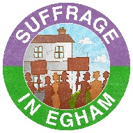
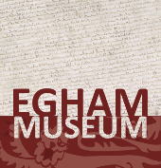
Suffrage in Egham Project:
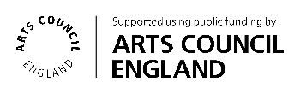
An Evening of Music and Drama

We are looking for performers to take part in a community event to commemorate the centenary of some women gaining the right to vote in the UK. We are looking to host the event at the Literary Institute in the evening of Friday 8th June 2018. We hope to get a variety of local choirs, bands and other performers to take part and where possible we would like to have a small exhibition on the history of each group based on any materials held in our collection at Egham Museum for the audience to look at before the show and during the interval.

As it is part of the Suffrage in Egham project (http://suffrage.eghammuseum.org/), we ask that each group performs something set/written in the early 20th century or that is related to suffrage in some way. Alternatively, performances may touch in some way on the topic of inspirational women. We are offering slots of 5 or 10 minutes.

If you have any ideas which you might like to perform please do not hesitate to put it forward. We are more than happy to take suggestions, but all must be approved prior to the event.

We will be creating a programme for the event, hiring the hall and promoting the performance on our website, social media and printed promotional material so it will come at no cost to you. Unless you require any particular costumes and props for your piece.

Please contact Amy Stone, Cultural Engagement Officer on suffrageproject@eghammuseum.org or 01784 434483 (Tuesday and Thursday only) for more information.

